Labuan Bajo Successfully Hosts 42nd ASEAN Summit

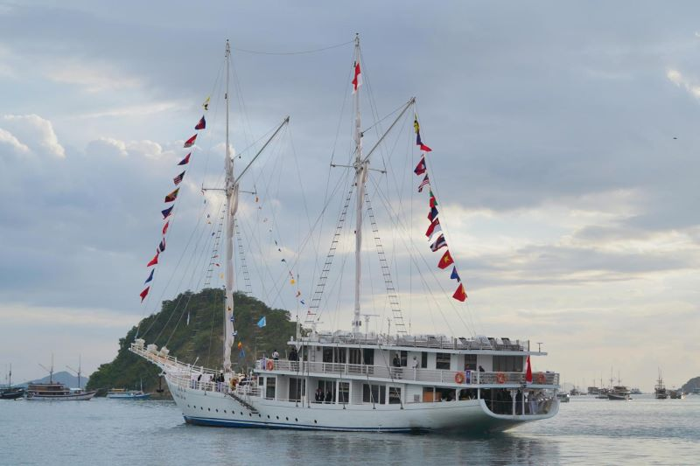
ASEAN leaders' afternoon tea session is taking place aboard the pinisi ship Ayana Lako Di'a.

Several parties considered the 42nd ASEAN Summit in Labuan Bajo, West Manggarai regency, East Nusa Tenggara (NTT) province, a success. The Summit from 9 to 11 May 2023 moved the Labuan Bajo community economy and gave an unforgettable impression and experience to the ASEAN countries delegates.
Indonesia managed to showcase the charm of its natural beauty during the Summit. The ASEAN delegations also got a special impression.
One of the special impressions given by Indonesia was an afternoon tea party while enjoying the sunset aboard the pinisi ship. Pinisi ship Ayana Lako Di'a or "good luck on the journey" in the Manggarai language witnessed the ASEAN heads of state togetherness. This special moment was a surprise brought by President Joko Widodo for ASEAN leaders.
A similar moment was also presented at the dinner for ASEAN Inter-Parliamentary Assembly (AIPA) delegation. It is a Southeast Asian countries' parliamentary forum that is a part of the 42nd ASEAN Summit series of events. The ASEAN parliament leaders also enjoyed an evening in Labuan Bajo and its surrounding islands aboard the pinisi ship.
The ASEAN Summit also brought positive impacts on the people in Labuan Bajo. The Summit has moved the Labuan Bajo community economy. It brought fortune not only for hotels as places to stay for delegates but also for several homes that were rented for homestays or home bases by the committee.
For several reasons, Labuan Bajo was chosen as the host of the 42nd ASEAN Summit. One of the reasons was that the Summit was the right moment to promote Labuan Bajo tourism and its natural beauty to the world. Moreover, Labuan Bajo is one of Indonesia's Five Super Priority Destinations to attract local and foreign tourists, including those from ASEAN countries.
The ASEAN Summit delegates had also been introduced to several attractions in Labuan Bajo, including Batu Cermin Cave, Rangko Cave, and Komodo National Park. Economic improvement after the ASEAN Summit is expected to generate Labuan Bajo's independent and sustainable tourism economy. Komodo Airport in Labuan Bajo has the potential to receive commercial flights from abroad even after the ASEAN Summit.
The development of Labuan Bajo as one of the super-priority destinations included airport expansion and improvement, seaport relocation, 25 km-long Labuan Bajo–Nalis Intersection–Kenari Intersection–Tanamori road construction, and bridges construction with a total length of 175 meters.
Labuan Bajo has possessed various MICE facilities and infrastructures that are expected to contribute to the achievement of the 8.5 million foreign tourists target this year and the creation of 4.4 million jobs as of 2024. Other positive impacts of the 42nd ASEAN Summit on Labuan Bajo were the development of data centers, hospitals, drinking water facilities, more than 10 new hotels, and other infrastructure development as well as the Komodo Airport runway extension.
The Labuan Bajo people and all Indonesians are honored to assume the 2023 ASEAN Chairmanship and successfully organize the 42nd ASEAN Summit.

Sources:
- kliklabuanbajo.id
- Kemenparekraf.go.id
- Antaranews.com
- Kompas.com

